
International UNIVERSITY OF Business Agriculture and TECHNOLOGY

Project Report on Books Store
Course Code-CSC 384(Programming in JAVA)

Submitted To
Rubayea Ferdows
Faculty
Department of Computer Science and Engineering
Submitted By

Team Name: BRo Code
Name | Id | Signature
Md. Moniruzzaman | 18103362
Osman Gani Mridul | 21103005
Shipto Chandra Das | 21103101
Anika Tasnim Eva | 20103128

Section-C
Program: BCSE
Date of Submission: 15/04/2023



Letter to Transmittal

15th April 2023
Rubayea Ferdows
Faculty,
IUBAT-International University of Business Agriculture and Technology
4 Embankment Drive Road, Sector-10,Uttara
Dhaka-1230, Bangladesh
Dear Mam,
It is great pleasure for us to submit our Proposal report on the topic entitled- Books Store. We have prepared this report to fulfil CSC 384 course. This report will help you to know about our project .We have tried our best to prepare this report to the required standard.
We are expressing our heartiest gratitude to you to go through this report and make your valuable marks . It would be very kind of you ,if u evaluate our performance regarding this report.
Yours Sincerely
On behalf of group BRo Code
Program: BCSE

Acknowledgements

In completing this minor project we have been fortunate to have help, support and encouragement from many people. we would like to acknowledge them for their cooperation.
First, We would like to thank our group leader project Md. Moniruzzaman, for guiding us through each and every step of the process with knowledge and support. Thank you for our all team member advice, guidance and assistance. We would also like to thank Rubayea Ferdows , Senior lecture of Computer Science and Engineering department of International University of Business Agriculture And Technology who always shows immense patience and understanding throughout the submission of project for whole department. Finally, we would like to dedicate this project to our Teachers and our parents, for their love, encouragement and help throughout the whole life.

With Regards,
Md. Moniruzzaman (18103362)
Osman Gani Mridul (21103005)
Shipto Chandra Das (21103101)
Anika Tasnim Eva (20103128)

Abstract
The main objective of the project is to create an online book store that allows users to search and
purchase a book online based on title, author and subject.

The users can order their books online through credit card payment. Using this Website the user can purchase a book online instead of going out to a book store and wasting time. There are many online book stores like Powell’s, Amazon which were designed using Html.

Bookstore application was initially developed by a group of 4 students. The app was a final term project for Object Oriented Eng Analysis and Design. I later improvised the app by adding a MySQL database for customers and books information, previously the information was stored in a text file at the end of the session. The GUI-based app was developed using JavaFX for frontend and Java for the backend. UML class and case diagrams were also developed during research and design phase. The app was implemented using the state design pattern and was applied to the customer class related to their status based on points, which they can earn when buying using cash or can reedem points to buy books.

DECLARATION

I am Osman Gani Mridul , on behalf on my group named-BRo Code, a student of BCSE program at IUBAT-International University of Business Agriculture and Technology .This is to inform you that the report – Books Store has been prepared for partial fulfilment of our CSC 384 course.

This report contains the field work, which has been performed by all of the group members of BRo Code .All Module and Procedure of this project inspection and internet information.

……………………………
Group: BRo Code
Program: BCSE

Contents

Chapter 1 .................................................................................... 6
1.1Introduction..............................................................................6
Chapter 2 .....................................................................................7
2.1 Literature Review ...................................................................7
Chapter 3 .....................................................................................8
3.1 Implementation Technologies.......................................................8

3.2 MySQL Database........................................................................9
3.3 A Home page with product catalog..............................................11
3.4 Project Design ..........................................................................13
3.5 Data Model ................................................................................13
Chapter 4 ...................................................................................15
4.1 Requirements.........................................................................15
4.2 Use Cases..............................................................................15
4.3 Maintain Account .................................................................16
4.4 Administrator........................................................................17
4.4 Administrator........................................................................17
4.4 Diagram…….........................................................................18
Chapter 5 ...................................................................................19
5.1 Code......................................................................................19
5.2 UML Diagram.......................................................................43
Chapter 6 ..................................................................................44
6.1 User Manual ........................................................................44
6.2 Conclusion ..........................................................................49

Chapter 1

Introduction

Welcome to our Book Store! We are delighted to have you here. Our Book Store is a haven for book lovers, offering a diverse and extensive collection of books to cater to a wide range of interests and preferences.
As you step into our store, you will be greeted by the inviting aroma of freshly printed books and the sight of shelves adorned with captivating covers that beckon you to embark on literary adventures. Our knowledgeable and friendly staff are always ready to assist you in finding the perfect book, whether you are seeking a thrilling mystery, a heartwarming romance, an insightful biography, a thought-provoking work of non-fiction, or any other genre that sparks your curiosity.
We take pride in curating a diverse selection of books that reflect the richness and diversity of the human experience, including works from acclaimed authors, emerging voices, and underrepresented perspectives. From bestsellers to hidden gems, classic literature to contemporary fiction, and books for all ages, our Book Store is a treasure trove for avid readers and book collectors alike.
In addition to our wide range of books, we also offer a cozy reading nook where you can curl up with a book and lose yourself in its pages. We frequently host author signings, book club discussions, and other literary events to foster a vibrant community of book enthusiasts.

Chapter 2

Literature Review

As an AI language model, I don't have access to external sources and cannot conduct a traditional literature review. However, I can provide you with a general overview of what a literature review is and its significance in the context of a book store.
A literature review is a critical and comprehensive analysis of existing literature and research on a particular topic or subject. It involves identifying, evaluating, and synthesizing relevant sources such as books, scholarly articles, and other publications related to the research question or topic at hand.
In the context of a book store, a literature review could focus on various aspects. Some possible areas of literature review related to a book store could include:
- Book market and industry analysis: This could involve examining literature related to the publishing industry, book market trends, consumer preferences, and purchasing behavior, as well as the impact of digital technology on the book industry.
- Customer behavior and preferences: This could involve reviewing literature on customer demographics, reading habits, genre preferences, and factors that influence book purchasing decisions.
- Bookstore management and operations: This could involve examining literature related to bookstore management, visual merchandising, inventory management, pricing strategies, and customer service in the context of bookstores.
- Community engagement and events: This could involve reviewing literature on the role of bookstores in fostering a literary community, hosting book-related events such as author signings, book clubs, and literary festivals, and creating a unique in-store experience for customers.
- Social and cultural significance of bookstores: This could involve examining literature that explores the social and cultural significance of bookstores as physical spaces for knowledge dissemination, literary culture, and fostering a sense of community among book lovers.
- Challenges and opportunities for bookstores: This could involve reviewing literature on the challenges and opportunities faced by bookstores in the digital age, such as competition from online retailers, changing reading habits, and evolving consumer expectations, as well as strategies for adapting and thriving in the modern book market.
A literature review provides a foundation for understanding the existing research and knowledge on a particular topic and helps identify gaps in the literature that may warrant further investigation. It serves as a critical component of academic research, business planning, and decision-making, providing valuable insights and informing strategies for a book store's succes
Chapter 3

Implementation Technologies

Introduction

As an AI language model, I can suggest some potential implementation technologies for a book store project. The choice of technologies would depend on various factors such as the specific requirements of the project, the scale of the book store, the budget, and the expertise of the development team. Here are some possibilities:
- E-commerce Platform: An e-commerce platform would be a key component of an online book store. Popular e-commerce platforms such as Shopify, WooCommerce, and Magento offer a range of features for setting up an online store, including product catalog management, shopping cart functionality, payment gateway integration, and order management. These platforms often provide customizable templates and themes to create a visually appealing and user-friendly online store.
- Content Management System (CMS): A CMS can be used to manage the content on the book store's website, such as product descriptions, author profiles, blog posts, and customer reviews. Popular CMS options like WordPress, Joomla, and Drupal offer flexible and extensible content management capabilities, allowing for easy updates and customization.
- Database Management System (DBMS): A DBMS would be required to store and manage the book store's inventory, customer data, order information, and other relevant data. Popular DBMS options like MySQL, PostgreSQL, and MongoDB offer robust and scalable database management solutions with efficient querying and data storage capabilities.
- Payment Gateway Integration: Secure and seamless payment processing is essential for an online book store. Popular payment gateways such as PayPal, Stripe, and Authorize.Net offer APIs and plugins that can be integrated into the e-commerce platform to facilitate online payments securely.
- Responsive Web Design: A responsive web design approach ensures that the book store's website is accessible and user-friendly across various devices, including desktops, tablets, and mobile devices. Front-end technologies such as HTML5, CSS3, and JavaScript can be used to create responsive and visually appealing web pages.
- Search and Recommendation Engines: Implementing search and recommendation engines can enhance the book store's website by helping customers discover books based on their preferences and browsing behavior. Technologies such as Elasticsearch, Apache Solr, and machine learning algorithms can be used to build robust search and recommendation features.
- Inventory and Order Management System: An inventory and order management system would be crucial for efficiently managing the book store's inventory, tracking orders, and managing shipments. Customized inventory and order management systems can be developed using programming languages such as Java, Python, or PHP, and frameworks like Laravel, Spring, or Django.
- Social Media Integration: Integrating social media platforms into the book store's website can help increase brand awareness, engage with customers, and drive traffic to the website. Social media APIs and plugins can be utilized to implement social sharing, customer reviews, and other social media integration features.

It's important to note that technology choices may evolve over time, and it's essential to consider factors such as scalability, security, usability, and budget while selecting and implementing technologies for a book store project. Consulting with experienced developers or technology experts can also be helpful in making informed decisions.

MySQL Database
MySQL is a popular and widely used relational database management system (DBMS) that can be a suitable choice for implementing the database for a book store project. Here are some considerations for using MySQL as the database technology for a book store project:
- Data Modeling: MySQL allows for the creation of a flexible and scalable database schema for modeling various entities such as books, authors, customers, orders, and inventory. It supports features such as tables, columns, indexes, constraints, and relationships (such as one-to-many and many-to-many), which can be utilized to design an efficient and organized database schema that can accommodate the specific data requirements of the book store.
- Performance and Scalability: MySQL is known for its performance and scalability, making it capable of handling large amounts of data and concurrent users. It supports advanced indexing and caching mechanisms that can optimize query performance, and it can be configured to handle high levels of concurrent connections, making it suitable for a book store project with potential future growth.
- Security: MySQL provides various security features to protect the database from unauthorized access and ensure data integrity. It supports user authentication and authorization mechanisms, encryption of data in transit and at rest, and audit logging. Proper security measures, such as using parameterized queries or prepared statements, can also be implemented in the application code to prevent SQL injection attacks.
- Compatibility and Integration: MySQL is compatible with many programming languages and frameworks, making it easy to integrate with different application development technologies. It has robust APIs and libraries for languages like PHP, Java, Python, and others, allowing for seamless interaction between the application and the database. It can also integrate with other technologies such as caching systems, search engines, and message queues to enhance the functionality of the book store application.
- Community and Support: MySQL has a large and active community of users, developers, and support resources, including extensive documentation, forums, and online resources. This can be advantageous for obtaining assistance, troubleshooting, and staying updated with the latest features and security patches.
- Cost-effectiveness: MySQL is an open-source DBMS, which means it is generally free to use, making it a cost-effective choice for a book store project compared to proprietary database solutions. However, it's important to consider any potential costs associated with hosting, maintenance, and support, depending on the implementation setup.
In conclusion, MySQL can be a suitable and cost-effective choice for implementing the database for a book store project, offering performance, scalability, security, compatibility, and community support. Proper data modeling, security measures, and integration with the application code can ensure the efficient and secure management of data for the book store project.

Web Page Programming Options book store
When building a book store website, there are several web page programming options available depending on your requirements, technology stack, and development preferences. Here are some popular web page programming options for a book store project:
HTML/CSS: HTML (Hypertext Markup Language) and CSS (Cascading Style Sheets) are the fundamental technologies for building web pages. HTML is used for creating the structure and content of web pages, while CSS is used for styling and layout. This is the basic foundation for building any web page, and most web development projects, including book store websites, would involve the use of HTML and CSS.
JavaScript: JavaScript is a widely used programming language that allows for dynamic and interactive web pages. It can be used to add functionality such as form validation, image sliders, shopping cart functionality, and other client-side interactions to a book store website. JavaScript can be used in conjunction with HTML and CSS to create engaging and interactive user experiences on the web pages.
Front-end Frameworks: Front-end frameworks such as Bootstrap, Foundation, and Materialize are popular options for building responsive and mobile-friendly web pages. These frameworks provide pre-designed components and styles that can be easily used to create consistent and visually appealing web pages for a book store. They also offer built-in responsiveness, which is essential for providing a seamless experience across different devices and screen sizes.
Server-side Programming: Server-side programming languages such as PHP, Python, Ruby, and Node.js can be used for implementing server-side logic and processing on a book store website. These languages allow for dynamic content generation, server-side data processing, and interaction with databases to manage book listings, customer information, and order processing.
Content Management Systems (CMS): CMS platforms such as WordPress, Joomla, and Drupal offer pre-built templates, themes, and plugins that can be used to quickly create a book store website without extensive coding. These CMS platforms often have built-in e-commerce functionality and can be customized to suit the specific needs of a book store, such as managing book inventory, processing orders, and handling customer accounts.
Full-stack JavaScript frameworks: Full-stack JavaScript frameworks such as MEAN (MongoDB, Express, Angular, Node.js) and MERN (MongoDB, Express, React, Node.js) are gaining popularity for building web applications, including book store websites. These frameworks allow for end-to-end development using a single programming language (JavaScript) for both front-end and back-end development, making it easier to maintain and scale the application.
Other technologies: Depending on the specific requirements of your book store project, there may be other web page programming options such as Angular, React, Vue.js, or other specialized libraries and frameworks that can be used for building complex user interfaces, handling data-intensive operations, or integrating with third-party APIs.
In conclusion, there are several web page programming options available for building a book store website, ranging from basic HTML/CSS to more advanced full-stack frameworks and CMS platforms. The choice of technology stack would depend on factors such as project requirements, team expertise, scalability needs, and development preferences. It's essential to carefully evaluate and choose the appropriate web page programming options that best fit your book store project's needs and goals.

A Home page with product catalog
The home page of a book store website typically serves as the landing page where visitors can get an overview of the store and access the product catalog. Here are some key components that can be included in the home page with a product catalog for a bookstore:
- Header: The header section typically contains the store logo, navigation menu, search bar, and possibly a shopping cart icon to access the shopping cart functionality.
- Hero Section: The hero section is a prominent area at the top of the home page that can feature eye-catching visuals, such as high-quality images of popular books, book covers, or book-related graphics, along with a compelling call-to-action (CTA) that encourages visitors to explore the catalog or make a purchase.
- Featured Books: This section can highlight a selection of featured books, such as bestsellers, new arrivals, or staff picks, with book covers, titles, authors, and brief descriptions. This can help visitors quickly discover popular books and generate interest in exploring more.
- Product Catalog: The main focus of the home page would be the product catalog, which can be displayed in a grid or list format, showcasing book covers, titles, authors, and pricing information. Visitors should be able to browse and filter the catalog based on different criteria such as genre, author, price range, and more.
- Search and Filtering Options: A search bar and filtering options can be provided to allow visitors to search for specific books or narrow down their options based on their preferences. This can enhance the user experience and help visitors find the books they are interested in more quickly.
- Call-to-Action (CTA) Buttons: Strategically placed CTA buttons throughout the home page can encourage visitors to take action, such as adding a book to the shopping cart, signing up for a newsletter, or exploring more book categories. CTAs should be visually appealing, easily clickable, and clearly convey the intended action.

Search
A search by keyword option is provided to the user using a textbox .The keyword to be entered should be either Book’s category or title.

Books
After successful log in user can navigate to this section to search for the books and then can add to cart. This page is restricted for not logged in user mean user can’t navigate to this page without log in to his/her account.

Managing user accounts
Each user should have an account to access all the functionalities of website. User can login using login page and logout using the logout page. All the user sessions will be saved in the database
.
Administration:
The Administrator will be provided with special functionalities like
- Add Books or its descriptions to the database.
- Edit Books or its descriptions to the database
- delete books or its descriptions to the database.
•check the books which been ordered.

Project Design

Designing a bookstore project involves creating a plan that outlines the overall look, feel, and functionality of the website. Here are some key components to consider when designing a bookstore project:
- User Interface (UI) Design: The user interface design should be visually appealing, easy to navigate, and intuitive for users to interact with. This includes designing a clean and organized layout, choosing appropriate typography and color schemes, and creating clear navigation menus that allow users to easily browse and search for books.
- Responsive Design: With the increasing use of mobile devices, it's important to ensure that the bookstore project is designed to be responsive, meaning it adapts to different screen sizes and devices. This ensures that users can have a seamless experience whether they are accessing the website on a desktop, tablet, or mobile phone.
- Product Catalog Design: The product catalog is the heart of a bookstore website, and its design is crucial in helping users discover and explore books. The catalog should be organized into categories or genres, with clear book cover images, book titles, authors, pricing information, and brief descriptions. Filtering and sorting options should also be available to help users narrow down their search and find books of interest.
- Search Functionality: A robust search functionality is essential for a bookstore website, allowing users to search for books based on keywords, authors, genres, or other criteria. The search bar should be prominently placed and easy to use, and the search results should be displayed in a clear and organized manner.
- Shopping Cart and Checkout Design: If the bookstore project includes e-commerce functionality, the shopping cart and checkout process should be designed to be user-friendly and secure. This includes designing a shopping cart that displays the selected books, allows users to modify quantities or remove items, and provides clear pricing and checkout options. The checkout process should be streamlined and secure, with clear instructions and multiple payment options.

Data Model
A data model is a conceptual representation of the structure and organization of data in a database. Here is a high-level overview of a potential data model for a bookstore:
Books Table: This table would store information about individual books, such as book ID, title, author, genre, publisher, publication date, ISBN, and pricing information. It may also include fields for book cover images, book descriptions, and customer reviews.
Customers Table: This table would store information about customers who register on the bookstore website, such as customer ID, name, contact information, billing and shipping addresses, and account details.
Orders Table: This table would store information about customer orders, such as order ID, customer ID, order date, and order status. It may also include fields for shipping information, payment details, and order total.
Order Items Table: This table would store information about individual items within an order, such as item ID, order ID, book ID, quantity, and price. This table would establish a many-to-many relationship between orders and books, as a single order can contain multiple items, and a single book can be included in multiple orders.
Wishlist Table: This table would store information about books that customers have added to their wishlist, such as customer ID and book ID. This table would establish a many-to-many relationship between customers and books, as a customer can have multiple books in their wishlist, and a book can be added to multiple wishlists.
Reviews Table: This table would store information about customer reviews for books, such as customer ID, book ID, rating, review text, and review date.
Categories Table: This table would store information about book categories or genres, such as category ID, category name, and category description. This table would establish a one-to-many relationship with the Books Table, as each book can belong to only one category, but each category can have multiple books.
Authors Table: This table would store information about book authors, such as author ID, author name, and author biography. This table would also establish a one-to-many relationship with the Books Table, as each book can have only one author, but each author can have multiple books.

Chapter 4

Requirements
The Main Requirements include Macromedia Dreamweaver 8 to develop the web application, MySQL and apache server to design the database and Google chrome as a main web browser to run the website.

Use Cases

Browse catalog
Search for a book
Purpose:
A user can search for a book of his choice by selecting category and title. Then a select query is used to retrieve data from the database and display the selected information.
Actor: User.
Input: The user will search book by title or category.
Output:
The system will display the books which matches the selected search criteria. A dataset is created as a result of select query. Later the dataset is binder to the data repeater to display the selected data.

Maintain Account

Register

Actor: User
Input: The user will enter details in the registration form according to fields. The fields include:
Username
Password

Output: After registration the user will be directed to the main home page.

Login

Purpose: If the user wants to get access to all the functionalities of Online Book Store he should login using his username and password.

Actor: User
Input: The user will enter his username and password.
Output: If it is a successful login the user will be directed to the main home page. Else it will show an error regarding user name or password.

Logout

10.3.1 Purpose: If the user wants to end his session and sign out of the website then he can use the logout option.

10.3.2 Actor: User
10.3.3 Input: The user will click the logout button. 10.3.4 Output: The user’s account session comes to an end and he should login again.

Administrator

Login
Purpose:
If the Administrator wants to get access to all the functionalities of Online Book Store he should login using his username and password.
Actor: Administrator
Input: The Administrator will enter his username and password.

Output:
If it is a successful login the Administrator will be directed to his menu page. Else if the Administrator enters invalid information he will be asked to check the entered information.

Check Order

Purpose: If the Administrator wants to check the selected and downloaded books he/she will navigate to this part.
Actor: Administrator
Input: by clicking that option Administrator can see all the selected books a longside with the user names

Diagram


Login
Log out
Add to cart
Register
Search
Login
Register
Add books
Check Order DD
Log out
Admin

Chapter 5
Code
BookstoreApp.java

package bookstoreapp;

import java.io.File;

import java.io.FileNotFoundException;

import java.sql.Connection;

import java.sql.DriverManager;

import java.sql.PreparedStatement;

import java.sql.ResultSet;

import java.sql.SQLException;

import java.sql.SQLIntegrityConstraintViolationException;

import java.sql.Statement;

import java.util.Scanner;

import java.util.logging.Level;

import java.util.logging.Logger;

import javafx.application.Application;

import static javafx.application.Application.launch;

import javafx.collections.ObservableList;

import javafx.event.ActionEvent;

import javafx.scene.layout.AnchorPane;

import javafx.event.EventHandler;

import javafx.scene.Scene;

import javafx.geometry.Insets;

import javafx.geometry.Pos;

import javafx.scene.control.Alert;

import javafx.scene.control.Button;

import javafx.scene.control.Label;

import javafx.scene.control.TableColumn;

import javafx.scene.control.TableView;

import javafx.scene.control.TextField;

import javafx.scene.control.cell.PropertyValueFactory;

import javafx.scene.layout.GridPane;

import javafx.scene.layout.VBox;

import javafx.stage.Stage;

import javafx.stage.WindowEvent;

import javafx.scene.layout.HBox;

public class BookstoreApp extends Application {

private Customer customer = null;

private Owner owner = null;

private double totalPrice;

private int count = 0;

private Connection con1;

private PreparedStatement DB;

@Override

public void start(Stage primaryStage) {

connection(); //initalize connection with DB server and get current books and customer info

Label user_id=new Label("User ID");

Label welcome = new Label("Welcome to the BookStore");

Label pass = new Label("Password");

Label fail = new Label();

TextField tf1=new TextField();

TextField tf2=new TextField();

Button register = new Button("Register");

Button login = new Button("Login");

GridPane root = new GridPane();

root.addRow(0, welcome);

root.addRow(1, user_id, tf1);

root.addRow(2, pass, tf2);

root.addRow(3,register, login);

root.addRow(4,fail);

login.setMaxWidth(100);

//top right bottom left offset

root.setPadding(new Insets(175, 10, 10,270));

root.setHgap(10);

root.setVgap(10);

Scene scene=new Scene(root,800,500);

primaryStage.setScene(scene);

primaryStage.setResizable(false);

primaryStage.setTitle("BookStore");

primaryStage.show();

login.setOnAction(new EventHandler<ActionEvent>() {

public void handle(ActionEvent event) {

String userName = tf1.getText().trim();

String password = tf2.getText().trim();

login(userName, password, primaryStage);

fail.setText("Username or password is incorrect");

}

});

register.setOnAction(new EventHandler<ActionEvent>() {

@Override

public void handle(ActionEvent event) {

registerCustomer(primaryStage);

}

});

close(primaryStage); //if 'X' is clicked in top right, save data before close

}

public void connection(){

if(count==0){

try{

String pass= DBpassword(); //database connection password

owner = Owner.getOwnerInstance(); //only one owner instance and load data once

Class.forName("com.mysql.cj.jdbc.Driver");

con1 = DriverManager.getConnection("jdbc:mysql://localhost/test","root",pass);

Statement s = con1.createStatement();

//get all the books data from DB

ResultSet res = s.executeQuery("SELECT * FROM booktable");

while(res.next()){

//fill the books obserablelist in the owner instance

String name = res.getString("BookName");

double price = res.getDouble("Price");

System.out.println(name + " " + price);

Books b = new Books(name,price);

owner.addBook(b);

}

//get all the customer data from DB

res = s.executeQuery("SELECT * FROM customertable");

while(res.next()){

String username = res.getString("name");

String password = res.getString("password");

int points = res.getInt("points");

System.out.println(username + " " + password);

Customer c = new Customer(username, password,points);

owner.addCustomer(c);

}

}catch(Exception e){

System.out.println(e);

}

count++;

}

}

public String DBpassword(){

File file = new File("DBpassword.txt");

try {

Scanner scan = new Scanner(file);

return(scan.nextLine());

} catch (FileNotFoundException ex) {

Logger.getLogger(BookstoreApp.class.getName()).log(Level.SEVERE, null, ex);

}

return "a";

}

public void registerCustomer(Stage primaryStage){

Label user_id=new Label("User ID");

Label pass = new Label("Password");

Label confirm = new Label();

TextField tf1=new TextField();

TextField tf2=new TextField();

Button register = new Button("Register");

Button back = new Button("back");

GridPane root = new GridPane();

root.addRow(0, user_id, tf1);

root.addRow(1, pass, tf2);

root.addRow(2,register, back);

root.addRow(4, confirm);

register.setMaxWidth(100);

//top right bottom left offset

root.setPadding(new Insets(175, 10, 10,270));

root.setHgap(10);

root.setVgap(10);

Scene scene=new Scene(root,800,500);

primaryStage.setScene(scene);

primaryStage.setResizable(false);

primaryStage.setTitle("BookStore");

primaryStage.show();

register.setOnAction(new EventHandler<ActionEvent>() {

@Override

public void handle(ActionEvent event) {

String username = tf1.getText().trim();

String password = tf2.getText().trim();

if(username.equals("") || password.equals("")){

Alert a = new Alert(Alert.AlertType.ERROR); //alert box

a.setContentText("Invalid Input"); //alert box content(message)

a.show(); //show the alert box

tf1.clear(); //clear addUsername textfield from user input

tf2.clear(); //clear addPassword textfield from user input

}else{

try{

owner.addCustomer(new Customer(username, password,0));

DB = con1.prepareStatement("INSERT INTO customertable(name, password) VALUES(?,?)");

DB.setString(1, username);

DB.setString(2, password);

DB.executeUpdate();

tf1.clear(); //clear addUsername textfield from user input

tf2.clear();

confirm.setText("New Customer Created");

}catch(SQLIntegrityConstraintViolationException e){

confirm.setText("Username already taken");

tf1.clear(); //clear addUsername textfield from user input

tf2.clear(); //clear addPassword textfield from user input

}catch(Exception e){

confirm.setText("Error! Try again");

tf1.clear(); //clear addUsername textfield from user input

tf2.clear(); //clear addPassword textfield from user input

System.out.println(e);

}

}

}

});

back.setOnAction(new EventHandler<ActionEvent>() {

@Override

public void handle(ActionEvent event) {

start(primaryStage);

}

});

}

public void login(String name, String pass, Stage primaryStage){

try{

Statement s = con1.createStatement();

ResultSet res = s.executeQuery("SELECT name,password FROM customertable WHERE name='" + name + "'");

if(!res.next()){ //false -> if customer/owner does not exist

return;

}else{ //true; get info

String username = res.getString("name");

String password = res.getString("password");

if(username.equals("admin") && password.equals("admin")){ //check is it owner?

ownerStage(primaryStage); //owner main screen

//return;

}else if(username.equals(name) && password.equals(pass)){ //check if its a cutomer, and get current customer instance

//already in try-catch don't need a new one

res = s.executeQuery("SELECT status,points FROM customertable WHERE name='" + name + "'");

//get customer info from database

res.next();

String status = res.getString("status");

int points = res.getInt("points");

//create the temp customer obj to use

customer = new Customer(name, pass, points);

if(status.equals("Silver")){

customer.setState(new SilverCustomer());

}else if(status.equals("Gold")){

customer.setState(new GoldCustomer());

}

System.out.println("Customer Username is: " + customer.getUsername());

customerScreen(primaryStage);

}else{

return;

}

//System.out.println(username + " " + password);

}

}catch(Exception e){

System.out.println(e);

}

}

public void customerScreen(Stage primaryStage){

ObservableList<Books> books = owner.getBooks();

//Top Label

Label label = new Label ("Welcome " + customer.getUsername() + ". You have " + customer.getPoints() + " points. Your Status is " + customer.getStatus().currentStatus() + ".");

label.setMaxWidth(Double.MAX_VALUE);

AnchorPane.setLeftAnchor(label, 0.0);

AnchorPane.setRightAnchor(label, 0.0);

label.setAlignment(Pos.CENTER);

//BookName Col

TableColumn<Books, String> bookNameColumn = new TableColumn<>("Book Name");

bookNameColumn.setMinWidth(266);

bookNameColumn.setCellValueFactory(new PropertyValueFactory<>("bookName"));

//Book Price col

TableColumn<Books, Double> bookPriceColumn = new TableColumn<>("Book Price");

bookPriceColumn.setMinWidth(266);

bookPriceColumn.setCellValueFactory(new PropertyValueFactory<>("bookPrice"));

//Select Col

TableColumn<Books, String> selectColumn = new TableColumn<>("Select");

selectColumn.setCellValueFactory(new PropertyValueFactory<>("Select"));

//table

TableView<Books> table = new TableView<>();

table.setItems(books);

table.getColumns().addAll(bookNameColumn, bookPriceColumn, selectColumn);

//Buy buttom

Button buy = new Button ("Buy");

//Redeem button

Button redeem = new Button("Redeem Points & Buy");

//Logout button

Button logout = new Button ("Logout");

GridPane grid = new GridPane();

grid.addRow(0, buy,redeem,logout);

grid.setPadding(new Insets(10,10,10,10)); //outter padding

grid.setHgap(10); //padding between each element

grid.setVgap(10);

grid.setAlignment(Pos.CENTER);

//parent pane

VBox root = new VBox();

root.getChildren().addAll(label,table,grid);

Scene scene = new Scene(root);

primaryStage.setScene(scene);

primaryStage.setTitle("BookStore");

primaryStage.show();

//Logout Function

logout.setOnAction(new EventHandler<ActionEvent>() {

public void handle(ActionEvent event) {

start(primaryStage);

}

});

//Buy Function

buy.setOnAction(new EventHandler<ActionEvent>() {

public void handle(ActionEvent event) {

totalPrice = 0;

totalPrice = buyBooksUsingCash();

buyScreen(primaryStage, totalPrice);

}

});

//Buy Function

redeem.setOnAction(new EventHandler<ActionEvent>() {

public void handle(ActionEvent event) {

totalPrice = 0;

totalPrice = buyBooksUsingPoints();

buyScreen(primaryStage, totalPrice);

}

});

close(primaryStage); //if 'X' is clicked in top right, save data before close

}

public double buyBooksUsingCash(){

double totalPrice = 0;

for(Books b: owner.getBooks()){

if(b.getSelect().isSelected()){

totalPrice = totalPrice+b.getBookPrice();

}

}

customer.buyCash(totalPrice);

updateCustomerDB();

return totalPrice;

}

public double buyBooksUsingPoints(){

double totalPrice = 0;

for(Books b: owner.getBooks()){

if(b.getSelect().isSelected()){

totalPrice = totalPrice+b.getBookPrice();

}

}

totalPrice = customer.buyPoints(totalPrice);

updateCustomerDB();

return totalPrice;

}

public void updateCustomerDB(){

try{

DB = con1.prepareStatement("UPDATE customertable SET status=?, points=? WHERE name='"+ customer.getUsername() + "'");

DB.setString(1, customer.getStatus().currentStatus());

DB.setInt(2, customer.getPoints());

DB.executeUpdate();

getCustomerDB(); //update the list of customer in owner with current DB value

System.out.println("Updated customer info");

}catch (Exception e){

System.out.println(e);

}

}

public void buyScreen(Stage primaryStage,double totalPrice){

//Top Label

Label label = new Label ("\n\n\nTotal Cost: " +totalPrice+ ". \nYou have " + customer.getPoints() + " points. \nYour Status is " + customer.getStatus().currentStatus() + ".");

label.setMaxWidth(Double.MAX_VALUE);

AnchorPane.setLeftAnchor(label, 0.0);

AnchorPane.setRightAnchor(label, 0.0);

label.setAlignment(Pos.CENTER);

//Logout button

Button logout = new Button ("Logout");

GridPane grid = new GridPane();

grid.setPadding(new Insets(10,10,10,10)); //outter padding

grid.addRow(10,logout);

grid.setHgap(10); //padding between each element

grid.setVgap(10);

grid.setAlignment(Pos.CENTER);

//parent pane

VBox root = new VBox();

root.getChildren().addAll(label,grid);

Scene scene = new Scene(root,300,300);

primaryStage.setScene(scene);

primaryStage.setTitle("BookStore");

primaryStage.show();

//Logout Function

logout.setOnAction(new EventHandler<ActionEvent>() {

public void handle(ActionEvent event) {

start(primaryStage);

}

});

close(primaryStage); //if 'X' is clicked in top right, save data before close

}

public void ownerStage(Stage primaryStage){

Button books = new Button("Books"); //books button

Button customer = new Button("Customer"); //customer button

Button logout = new Button("Logout"); //logout button

GridPane root = new GridPane();

root.addRow(0, customer);

root.addRow(1, books);

root.addRow(2, logout);

books.setMaxWidth(100); //button max width

customer.setMaxWidth(100);//button max width

logout.setMaxWidth(100);//button max width

//top right bottom left offset

//center options

root.setPadding(new Insets(175, 10, 10,270));

root.setHgap(10); //hor and ver gap between each elements

root.setVgap(10);

Scene scene=new Scene(root,800,500);

primaryStage.setScene(scene);

primaryStage.setTitle("BookStore");

primaryStage.show();

customer.setOnAction(new EventHandler<ActionEvent>() {

@Override

public void handle(ActionEvent event) {

ownerCustomerScreen(primaryStage); //add customer screen

}

});

books.setOnAction(new EventHandler<ActionEvent>() {

@Override

public void handle(ActionEvent event) {

rendersBooksScreen(primaryStage); //renders book screen

}

});

logout.setOnAction(new EventHandler<ActionEvent>() { //logout

public void handle(ActionEvent event) {

start(primaryStage); //main screen

}

});

close(primaryStage); //if 'X' is clicked in top right, save data before close

}

public void rendersBooksScreen(Stage primaryStage){

ObservableList<Books> books = owner.getBooks(); //gets current books list

//Name Column

TableColumn<Books, String> nameColumn = new TableColumn<>("Book Name");

nameColumn.setMinWidth(350);

nameColumn.setCellValueFactory(new PropertyValueFactory<>("bookName"));

//Price Column

TableColumn<Books, Double> priceColumn = new TableColumn<>("Book Price");

priceColumn.setMinWidth(150);

priceColumn.setCellValueFactory(new PropertyValueFactory<>("bookPrice"));

//Input book name

TextField inputName = new TextField();

inputName.setPromptText("Name");

inputName.setMinWidth(100);

Label bookName = new Label("Name: ");

bookName.setPadding(new Insets(5,0,0,0)); //padding inside the label

//Input book price

TextField inputPrice = new TextField();

inputPrice.setPromptText("Price");

inputPrice.setMinWidth(100);

Label bookPrice = new Label("Price: ");

bookPrice.setPadding(new Insets(5,0,0,0));

Button addBookButton = new Button("Add");

Button deleteBookButton = new Button("Delete");

Button backButton = new Button("Back");

HBox hBox1 = new HBox();

hBox1.setPadding(new Insets(25, 25, 15, 25));

hBox1.setSpacing(10);

hBox1.getChildren().addAll(bookName, inputName,bookPrice, inputPrice, addBookButton);

HBox hBox2 = new HBox();

hBox2.setPadding(new Insets(0, 25, 25, 20));

hBox2.setSpacing(10);

hBox2.getChildren().addAll(deleteBookButton, backButton);

TableView<Books> booksTable = new TableView<>();

booksTable.setItems(books);

booksTable.getColumns().addAll(nameColumn, priceColumn);

VBox vBox = new VBox();

vBox.getChildren().addAll(booksTable, hBox1, hBox2);

Scene scene = new Scene(vBox);

primaryStage.setScene(scene);

primaryStage.show();

addBookButton.setOnAction(new EventHandler<ActionEvent>() {

@Override

public void handle(ActionEvent event) {

String bookName = inputName.getText().trim();

String bookPrice = inputPrice.getText().trim();

try{

if(isBookUnique(bookName, Double.parseDouble(bookPrice), books)){

double price = Double.parseDouble(bookPrice);

Books b = new Books(bookName, price);

booksTable.getItems().add(b);

//add the book to the DB

DB = con1.prepareStatement("INSERT INTO booktable(BookName, Price) VALUES(?,?)");

DB.setString(1, bookName);

DB.setDouble(2, price);

DB.executeUpdate();

return;

}

Alert duplicateBookAlert = new Alert(Alert.AlertType.INFORMATION);

duplicateBookAlert.setContentText("Invalid Input");

duplicateBookAlert.show();

}

catch(NumberFormatException e){

Alert invalidInputAlert = new Alert(Alert.AlertType.ERROR);

invalidInputAlert.setContentText("Invalid Input.");

invalidInputAlert.show();

}

catch (Exception e){

System.out.println(e);

}

finally {

inputName.clear();

inputPrice.clear();

}

}

});

deleteBookButton.setOnAction(new EventHandler<ActionEvent>() {

@Override

public void handle(ActionEvent event) {

ObservableList<Books> allBooks, selectedBook;

allBooks = booksTable.getItems();

selectedBook = booksTable.getSelectionModel().getSelectedItems();

for(Books b: selectedBook){ //delete selected books from the DB

try {

//issue is with trailing space and it changing word length and meesing up comparision.

DB = con1.prepareStatement("DELETE FROM booktable WHERE BookName = ?");

DB.setString(1, b.getBookName());

DB.execute();

} catch (SQLException ex) {

Logger.getLogger(BookstoreApp.class.getName()).log(Level.SEVERE, null, ex);

}

}

selectedBook.forEach(allBooks::remove);

}

});

backButton.setOnAction(new EventHandler<ActionEvent>() {

@Override

public void handle(ActionEvent event) {

ownerStage(primaryStage); //go to ownerStage

}

});

close(primaryStage);

}

public void ownerCustomerScreen(Stage primaryStage){

ObservableList<Customer> customers= owner.getCustomersList(); //get current books list

//username Col

TableColumn<Customer, String> usernameColumn= new TableColumn<>("Username");//create username col

usernameColumn.setMinWidth(266); //min col width

usernameColumn.setCellValueFactory(new PropertyValueFactory<>("username")); //(tie the data to col)get the values from obslist and all "username" var values

//password col

TableColumn<Customer, String> passwordColumn= new TableColumn<>("Password");//create password col

passwordColumn.setMinWidth(266);//min col width

passwordColumn.setCellValueFactory(new PropertyValueFactory<>("password"));//get the values from obslist and all "password" var values

//points col

TableColumn<Customer, Double> pointsColumn= new TableColumn<>("Points"); //create points col

pointsColumn.setMinWidth(266);//min col width

pointsColumn.setCellValueFactory(new PropertyValueFactory<>("points"));//get the values from obslist and all "points" var values

//table

TableView<Customer> table = new TableView<>(); //create tableview obj

table.setItems(customers); //set items to customers list

table.getColumns().addAll(usernameColumn, passwordColumn, pointsColumn); //add the cols to the table

//Username Textfield

TextField addUsername = new TextField(); //password textfield

addUsername.setPromptText("Username"); //placeholder text

addUsername.setMinWidth(300); //min width

Label usernameLabel = new Label("Username");

//Password Textfield

TextField addPassword = new TextField();

addPassword.setPromptText("Password");

addPassword.setMinWidth(300);

Label passwordLabel = new Label("Password");

//Add buttom

Button add = new Button ("Add");

//Delete button

Button delete = new Button("Delete");

//Back button

Button back = new Button ("Back");

GridPane grid = new GridPane();

grid.addRow(0, usernameLabel,addUsername, passwordLabel,addPassword, add); //add all the fields and button in one row

grid.addRow(1,delete,back); //delete and back button

grid.setPadding(new Insets(10,10,10,10)); //outter padding

grid.setHgap(10); //hor and ver between each element

grid.setVgap(10);

//parent pane

VBox root = new VBox();

root.getChildren().addAll(table, grid); //add table and gridpane

Scene scene = new Scene(root); //scene

primaryStage.setScene(scene); //main window scene

primaryStage.setTitle("BookStore"); //window title

primaryStage.show(); //show main window

add.setOnAction(new EventHandler<ActionEvent>() { //add customer button

@Override

public void handle(ActionEvent event) {

//trim() removes leading and trailing white space

String name = addUsername.getText().trim(); //entered username paramter

String password = addPassword.getText().trim(); //entered password parameter

if(validateCustomerUsername(name,password,customers)){ //Check if customer with same exist or not, if not then add it

//create customer obj

try{

DB = con1.prepareStatement("INSERT INTO customertable(name, password) VALUES (?,?)");

DB.setString(1, name);

DB.setString(2, password);

DB.executeUpdate();

System.out.println("Added new customer");

}catch (Exception e){

System.out.println(e);

}

Customer c = new Customer(name,password, 0); //create new customer onj

c.setState(new SilverCustomer()); //new customer is silver

table.getItems().add(c); //add new customer obj to the table

owner.setCustomersList(table.getItems()); //set customerlist list to the current table list

addUsername.clear(); //clear addUsername textfield from user input

addPassword.clear(); //clear addPassword textfield from user input

}else{ //error, customer username already exist

Alert a = new Alert(Alert.AlertType.ERROR); //alert box

a.setContentText("Invalid Input"); //alert box content(message)

a.show(); //show the alert box

addUsername.clear(); //clear addUsername textfield from user input

addPassword.clear(); //clear addPassword textfield from user input

}

}

});

delete.setOnAction(new EventHandler<ActionEvent>() {

@Override

public void handle(ActionEvent event) {

ObservableList<Customer> allCustomers, selectedCustomer; //temp lists

allCustomers = table.getItems(); //get all table item

selectedCustomer = table.getSelectionModel().getSelectedItems(); //get the selected item(obj)

for(Customer c: selectedCustomer){ //delete selected books from the DB

try {

//issue is with trailing space and it changing word length and meesing up comparision.

DB = con1.prepareStatement("DELETE FROM customertable WHERE name = ?");

DB.setString(1, c.getUsername().trim());

DB.execute();

} catch (SQLException ex) {

Logger.getLogger(BookstoreApp.class.getName()).log(Level.SEVERE, null, ex);

}

}

selectedCustomer.forEach(allCustomers::remove); //delete the selected customer from the list

owner.setCustomersList(table.getItems()); //set customerlist list to the current table list

}

});

back.setOnAction(new EventHandler<ActionEvent>() {

@Override

public void handle(ActionEvent event) {

owner.setCustomersList(table.getItems()); //set customerlist list to the current table list

//table.getItems().clear(); //clear table (dont do it, since i copy table to list, it will over ride the list (have to deep copy then)).

ownerStage(primaryStage); //go to ownerStage

}

});

close(primaryStage); //if 'X' is clicked in top right, save data before close

}

public void getCustomerDB(){

//null the prev customer list and update it with current DB values

try{

owner.voidCustomer();

Statement s = con1.createStatement();

ResultSet res = s.executeQuery("SELECT * FROM customertable");

while(res.next()){

String username = res.getString("name");

String password = res.getString("password");

int points = res.getInt("points");

System.out.println(username + " " + password);

Customer c = new Customer(username, password,points);

owner.addCustomer(c);

}

}catch(Exception e){

System.out.println(e);

}

}

public boolean validateCustomerUsername(String name,String password, ObservableList<Customer> customers){

if(name.equals("") || password.equals("") || name.equals("admin")){ //if empty field then false

return false;

}

for(Customer c: customers){ //loop through all the customers list

if(c.getUsername().equals(name.trim())){ //if username already exist then false

return false;

}

}

return true; //true if username does not exist

}

public boolean isBookUnique(String bookName, double bookPrice, ObservableList<Books> books){

if(bookName.equals("")){

return false;

}

if(bookPrice <=0){

return false;

}

for(Books book: books){

// && book.getBookPrice() == bookPrice

System.out.println(book.getBookName().equals(bookName));

System.out.println(bookName.length());

System.out.println(book.getBookName().length());

if(book.getBookName().equals(bookName)){

return false;

}

}

return true; //true if book does not exist already

}

public void close(Stage primaryStage){

primaryStage.setOnCloseRequest(new EventHandler<WindowEvent>() {

@Override

public void handle(final WindowEvent event) {

//System.out.println("Saved Data");

primaryStage.close(); //close main window

}

});

}

/**

* @param args the command line arguments

*/

public static void main(String[] args) {

launch(args);
}

UML Diagram

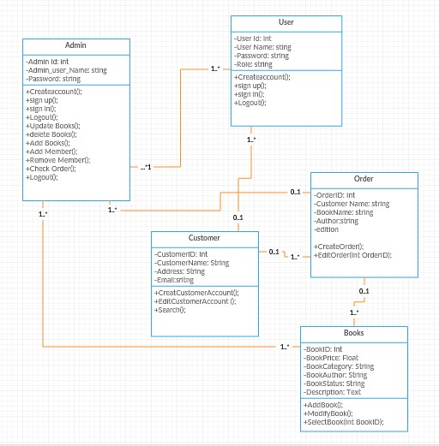

Figure: UML Diagram

Chapter 6

User Manual

Home page
When we run the Book Store first home page is displayed. The home page will appear as below. The user and Admin will have different rights.

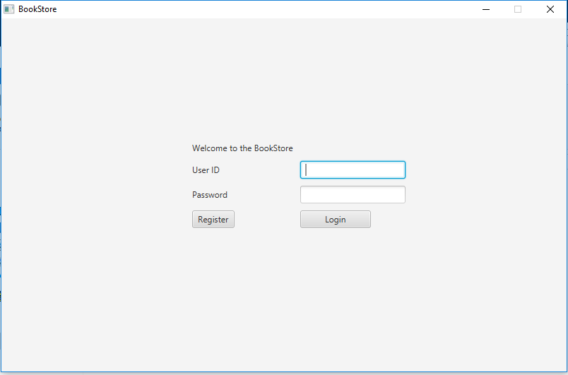

Figure: Home Page

If you are a new user you can register using the register link or if you are already a user you can login to purchase book and pay using the checkout. Any common user can use the search option in the home page to search for a book according to his/her choice by entering a Title of the book

Sign up page

A user should enter all the required fields’ information. After entering the specified information user should click the submit button to register.

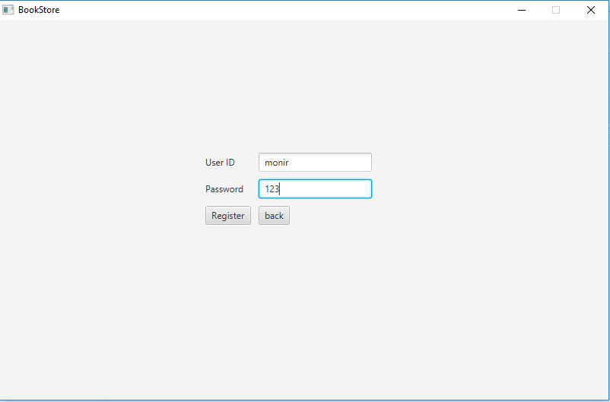

Figure : Sign up Page

Login page

After successfully registration you can login to the Website. Login page is used to login to the website. Login page will appear as below.

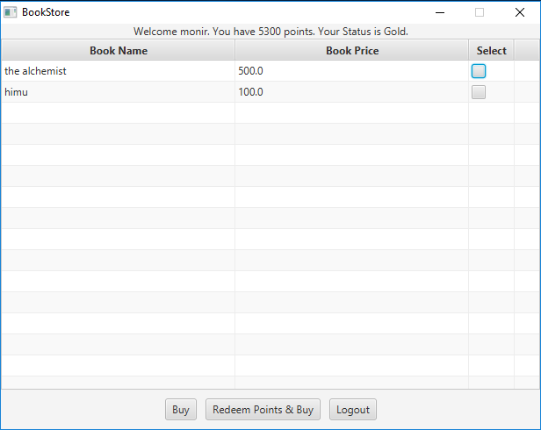

Figure : Login Page

Books

After successful login customre can navigate to the Book page where you can search several kinds of Books by title,category and then he/she can select the book by clicking on provided link under the book image and then can add to cart .
A customer without sign in to his/her account can not navigate to this page.This page is appearing as below.

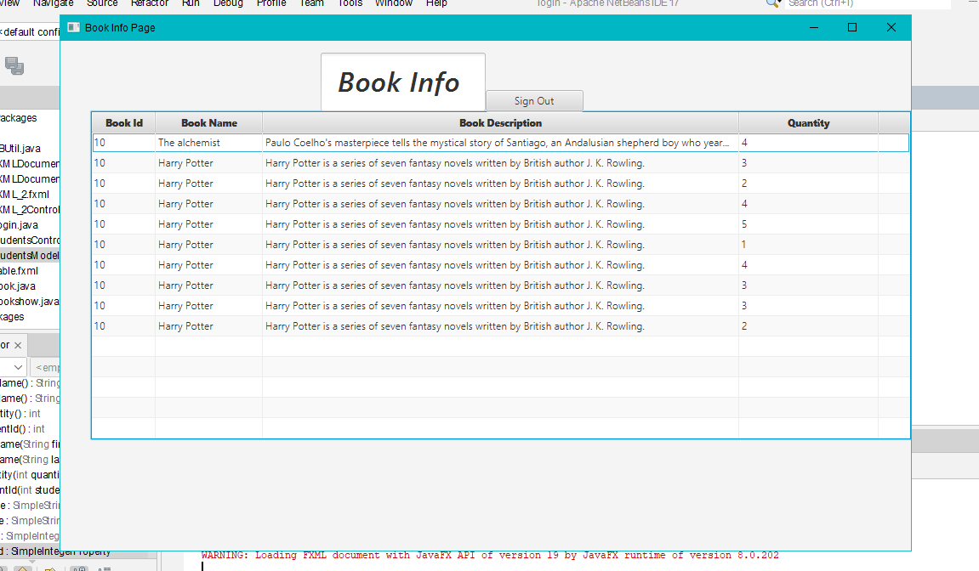

Figure: Books Page

Insert Books Page

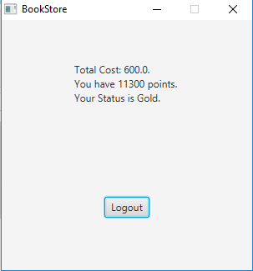

Figure: : Buy Books Page

Conclusion

In conclusion, the development of a bookstore project involves various aspects such as designing a user-friendly website with a product catalog, implementing a robust MySQL database for storing and managing book-related data, utilizing web page programming technologies, and designing a data model to organize and structure the data efficiently. The successful implementation of these components can result in a functional and interactive online bookstore that provides a seamless experience for customers to browse and purchase books.
A well-designed user interface and intuitive navigation can enhance the user experience, making it easy for customers to search, browse, and select books from the catalog. Efficient database design and implementation using MySQL can ensure smooth data management, including book information, customer details, orders, wishlists, reviews, and other relevant data. Utilizing suitable web page programming technologies, such as HTML, CSS, and JavaScript, can enable dynamic and interactive web pages that enhance the user experience and functionality of the bookstore website.
Designing a comprehensive data model is crucial for organizing and structuring the data in a logical and efficient manner. Properly defining relationships between entities, such as books, customers, orders, categories, authors, and publishers, can ensure accurate data retrieval and management, as well as support future scalability and expansion of the bookstore project.
In conclusion, a well-designed and implemented bookstore project can provide an engaging and convenient online platform for customers to explore, purchase, and review books. Careful consideration of user experience, database design, web page programming, and data modeling can contribute to the success of the bookstore project, resulting in a functional and user-friendly online bookstore that meets the needs of book lovers and supports the growth of the business.

THANK YOU

